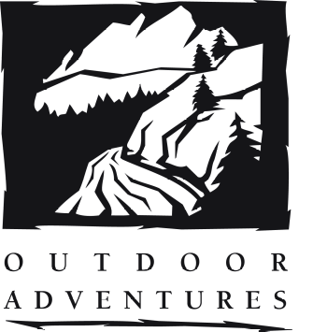
South Fork
Whitewater Rafting
Fact Sheet

Thank you for signing up for an Outdoor Adventure Whitewater Rafting trip!!! We could not be more excited to take you on a fun-filled, one-day trip down the South Fork of the American River. The 12-mile section of river we run begins at Camp Lotus and ends at Folsom Lake. Please read below for an overview of your trip with important details included:

Transportation

You must provide your own transportation to Camp Lotus the morning of the trip. It is each participant’s responsibility to find transportation to and from the river. Our meeting location in the morning is Camp Lotus, 5461 Bassi Rd Lotus, CA 95651, which is approximately 1 hour and 15 min from Davis. Please arrive at this location at 10:00am. Parking for the day at our boat put-in location costs $4 per vehicle. There will be an office upon arrival where you can make the payment.

Google Maps Directions from Outdoor Adventures, Davis to Camp Lotus

Clothing/ Items to Bring

Please Note: Cotton is strongly discouraged because of its cooling properties

- Shirt (long/short sleeve) to prevent sunburn - Swimsuit
- Tennis shoes/sandals w/ankle strap (no flip flops or crocs) - Nylon shorts
- Hat for shade w/leash - Sunglasses w/leash
- Change of clothes and towel when you return to your car - Sunscreen

Food

This trip does not include food, so eat a hearty breakfast and pack snacks and a lunch in a non-crushable container. We recommend a plastic Tupperware that contains your lunch. A ziplock bag will work but your lunch may be crushed! Bring something to drink (no alcohol and no glass bottles or containers that are likely to break/leak). Each raft will have a water jug as a backup for communal water, but everyone should still bring a water bottle!

What Outdoor Adventures Will Provide

- Wetsuits - Splash jackets
- Helmets - PFDs (life jackets)
- Paddles - Communal first aid and safety gear

Overview of our Day!

Upon arriving at Camp Lotus at 10:00am and paying for parking, you will meet your guides for the day, change into river-ready clothes/gear, and learn basic rafting safety information before hoping on the river. Once on the water, you will go through a brief introduction by one of our experienced guides on proper paddling technique, basic commands, and a chance to test your new skills on Class II rapids. Lunch will be held at OA’s beach site along the river. After a short lunch, you will enter The Gorge and face the Class III rapids of Satan’s Cesspool, Hospital Bar, and others. We generally reach Folsom Lake (the end of our trip) around 4:00pm. The day ends with a 30 minute bus ride back to your vehicles at Camp Lotus.

We can’t wait to see you out there!

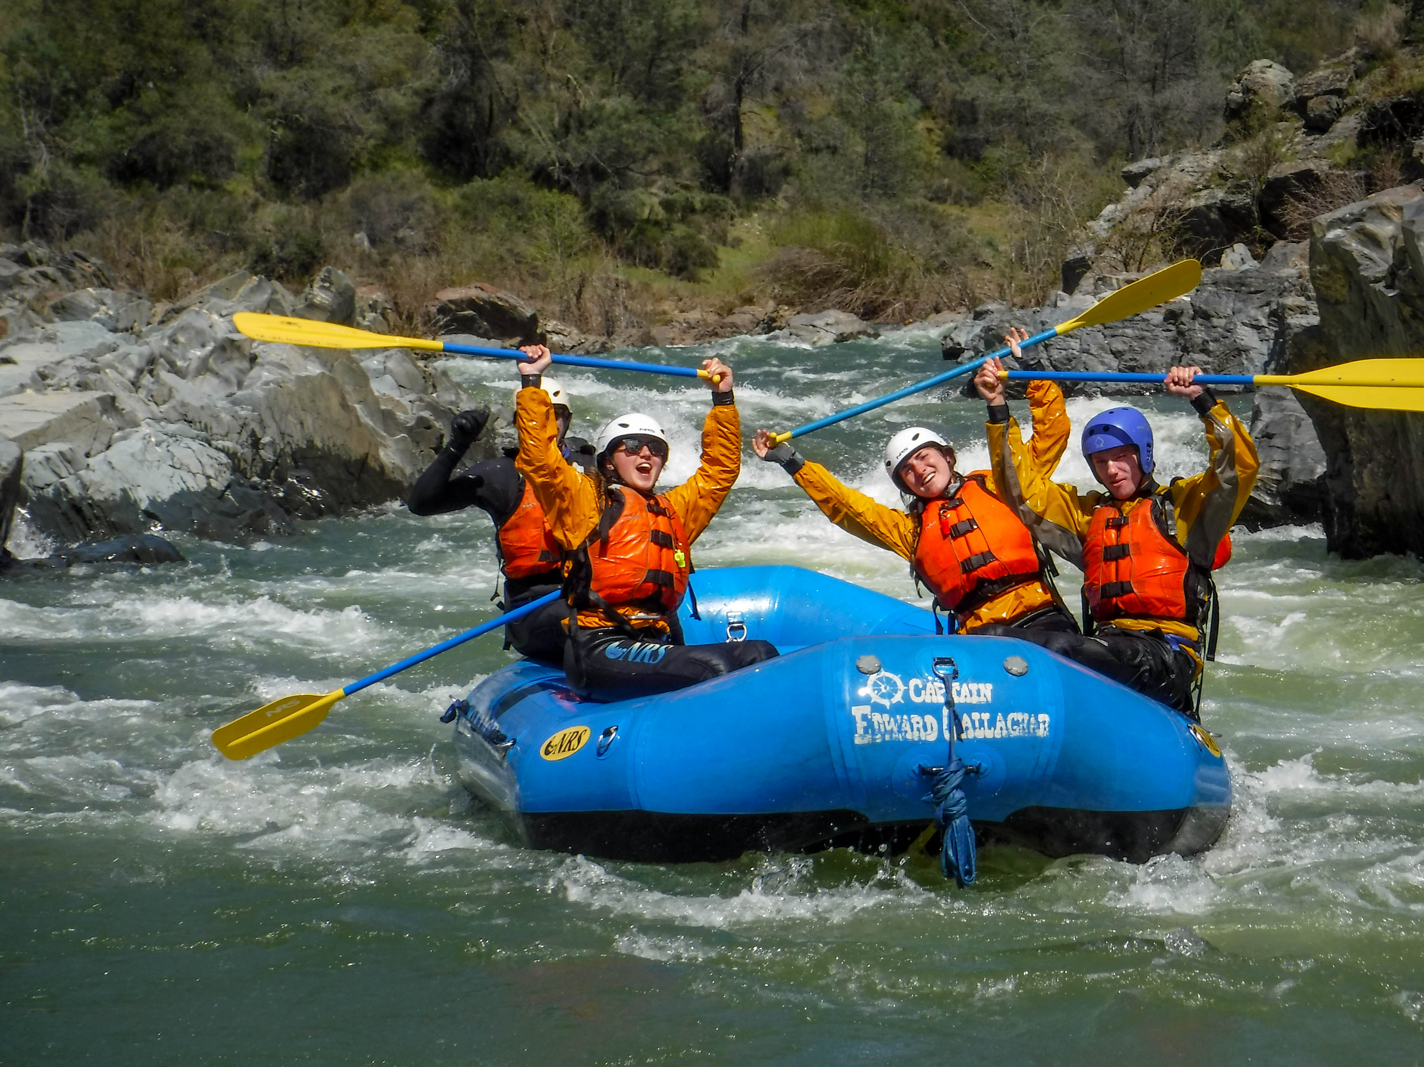

Youth Rafters: No one under the age of 12 can participate in any of OA’s classes or trips.

Cancellation/Refund Policy

All reservations are final. Refunds will be granted only if we can sell your spot on the trip or if OA cancels the class for any reason. If a trip is cancelled by OA you will receive a full refund. If you cancel your spot and we can sell it, you will be given a full refund in OA credit or a refund minus $10 processing fee.

Participants who are intoxicated or under the influence of illegal drugs will not be allowed on the trip.

If you have any questions, please call the OA Rental Center at (530)752-1995!

